Azure Key Vault Configurations

**Step 1. Create Azure Key Vault Resource group typing in ‘Key Vault’**

Com-ServiceName-ResouceGroup-identity-environment

Co-kv-rg-mg-dev

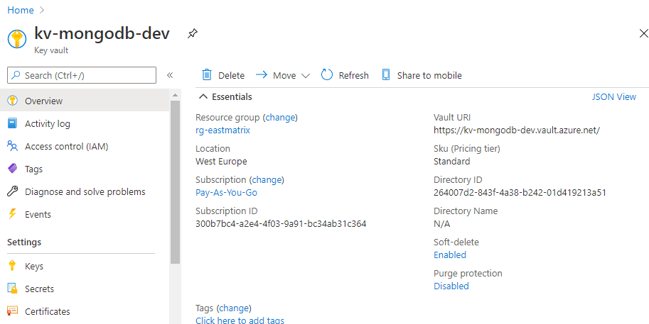

**Step 2. Add Secret**

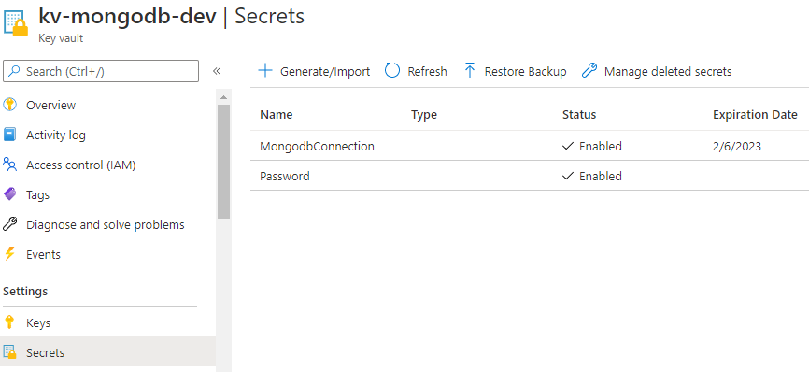

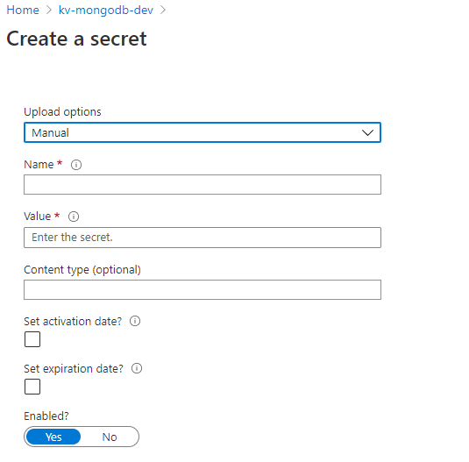

**Step 3. App Registration**

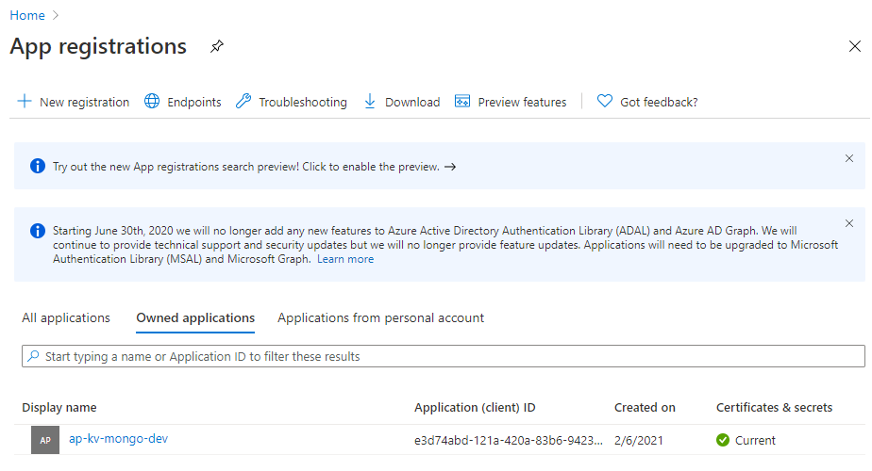

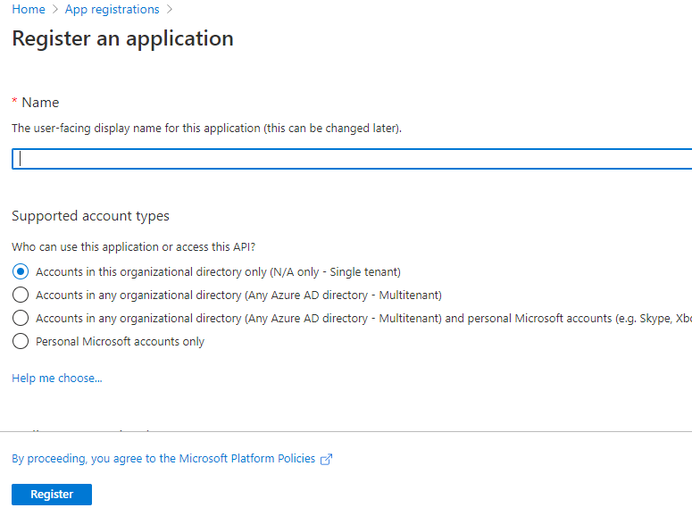

**Step 4. Providing Access to Key Vault via Registered App**

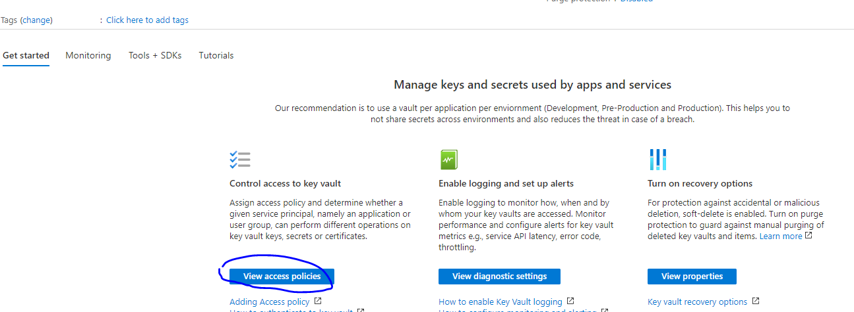

**Step 5. Certificate & Secrets**

